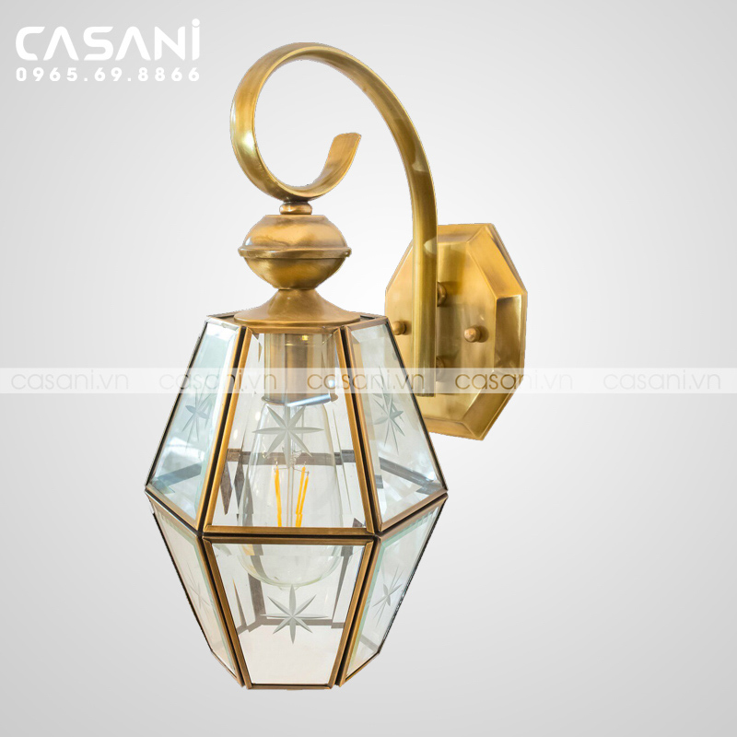

$78

- Product name: Copper glass wall lamp

- Product code: DTD-3334

- Material: copper

- Design: classic, luxurious

- Size: 22x35cm

- Bulb type: LED

- Status: In stock

- Warranty: 12 months

- Application: used as decorative lights for bedrooms, living rooms, bathrooms, hallways, walls surrounding the house, doors,...